**Spring Security : Authentication Architecture**

Here is the diagram for demonstrating list of classes and filters involved in spring security authentication process.

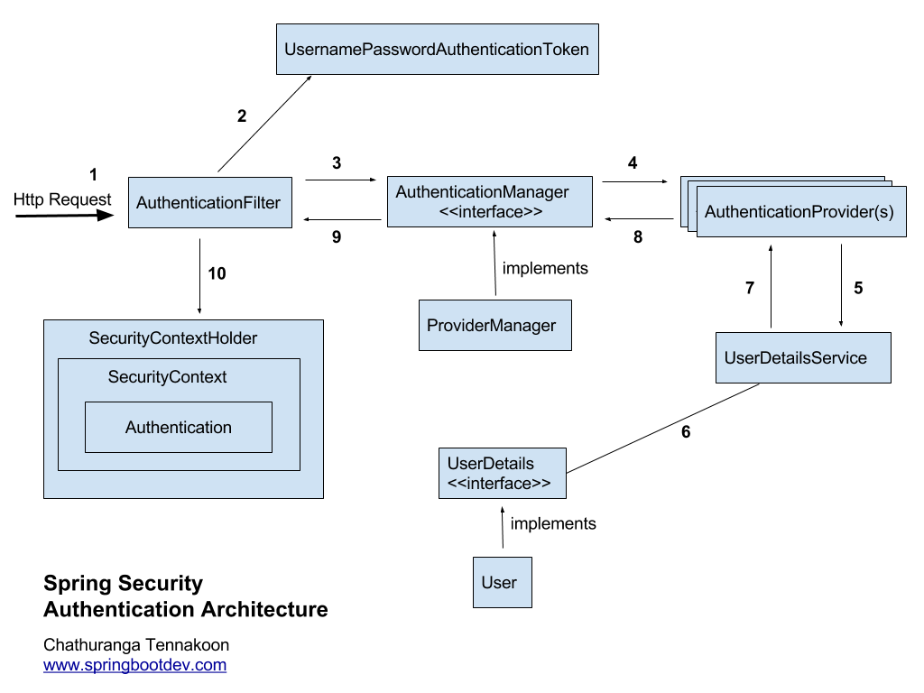

1. **Received the Http Request**

Spring security has a series/chain of filters. Therefore when a request comes, it will go through a chain of filters for authentication and authorization purposes. When there is an user authentication request, that will also go through the chain of filters as usual until it finds the relevant Authentication Filter based on the authentication mechanism/model.

E.g:- HTTP Basic authentication request goes through the chain of filters until it reaches the **BasicAuthenticationFilter**.

HTTP Digest authentication request goes through the chain of filters until it reaches the **DigestAuthenticationFilter**.

Login form submission request (login form authentication request)  goes through the chain of filters until it reaches the **UsernamePasswordAuthenticationFilter**.

x509 authentication request goes through the chain of filters until it reaches the **X509AuthenticationFilter** etc…

**2. Creates AuthenticationToken based on user credentials**

Once the authentication request is received by the relevant AuthenticationFilter, it extracts the **username** and **password** from the received request (most of the authentication mechanism require username and password). After that it creates an Authentication object based on the extracted user credentials.

If the extracted credentials are username and password, then **UsernamePasswordAuthenticationToken** will be created using username and password extracted/found.

**3. Delegating created AuthenticationToken for AuthenticationManagager**

After creating the **UsernamePasswordAuthenticationToken** object ,it will be used to invoke the **authenticate** method of the **AuthenticationManager**. AuthenticationManager is a just an interface and actual implementation is **ProviderManager**.

**AuthenticationManager.java**

|  |  |
| --- | --- |
| 1  2  3  4 | public interface AuthenticationManager  {    Authentication authenticate(Authentication authentication)throws  AuthenticationException;  } |

ProviderManager has a list of configured **AuthenticationProvider**(s) that should be used for authenticating user requests. ProviderManager will go through each of the provided AuthenticationProvider(s) and try to authenticate the user based on the passed Authentication Object (e.g:- **UsernamePasswordAuthenticationToken**)

**4.Trying to authenticate with list of AuthenticationProvider(s)**

**AuthenticationProvider** tries to authenticate user with provided authentication object.

|  |  |
| --- | --- |
| 1  2  3  4  5  6 | public interface AuthenticationProvider {        Authentication authenticate(Authentication authentication)  throws AuthenticationException;        boolean supports(Class<?> authentication);  } |

Here are some of the existing authentication providers that comes with the framework:

* CasAuthenticationProvider
* JaasAuthenticationProvider
* DaoAuthenticationProvider
* OpenIDAuthenticationProvider
* RememberMeAuthenticationProvider
* LdapAuthenticationProvider

**5. UserDetailsService Required?**

Some of the AuthenticationProvider may use **UserDetailsService** for retrieving the user details based on the username. (e.g:- **DaoAuthenticationProvider**)

|  |  |
| --- | --- |
| 1  2  3  4 | public interface UserDetailsService  {    UserDetails loadUserByUsername(String username) throws  UsernameNotFoundException;  } |

**6 and 7** . **UserDetails or User Object?**

 UserDetailsService will retrieve the UserDetails (actual implementation is User) based on the username.

**8. Authentication Object Or AuthenticationException?**

If the user is successfully authenticated, then the fully populated Authentication object will be returned. Otherwise an **AuthenticationException** will be thrown.  
According to the **AuthenticationProvider** interface,  AuthenticationProvider will exactly return fully populated authentication object (on successful authentication) or throw an **AuthenticationException** (on authentication failure)

**Fully populated Authentication Object**

authenticated – true

grant authorities list

user credentials (username only)

If any **AuthenticationException** is thrown, that will be handled by the configured **AuthenticationEntryPoint** that supports for the authentication mechanism.

**9. Authentication is done!**

AuthenticationManager will return the obtained fully populated Authentication object back to the relevant Authentication Filter.

**10. Setting up Authentication Object in SecurityContext**

Then the related AuthenticationFilter will store the obtained authentication object in the **SecurityContext** for future filter uses. (Use for Authorization Filters)

**SecurityContextHolder.getContext().setAuthentication(authentication);**